Majick Migration

Karika Shah | Malik Awan | Justin Parker

Summary:

* We set out to investigate the patterns of change in the yearly migration patterns of various species.
* If we found a trend, we would attempt to link the trend to an observable shift in influencing environmental factors.
* We were able to identify the presence/absence in most of the analyzed species, however, we were unable to link the trends to specific environmental factors.

Arctic Tern:

* We investigated a dataset containing several decades worth of fragmented location data for flocks of birds
* The data set was cleaned to remove data points not including one of the following:
  + Timestamp of location
  + 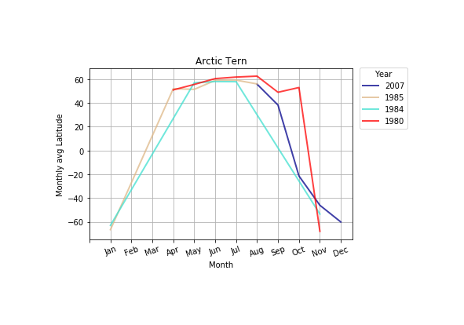Longitude or Latitude
* Mean values and deviation were taken for latitude by month to give an overview of the migration pattern
* The data showed variation year over year but over 2.5 decades, little change to the overall pattern was observed
* Plot representing above observations:

Blue Whales:

* We investigated a dataset containing several years worth of location data for pods of whales
* 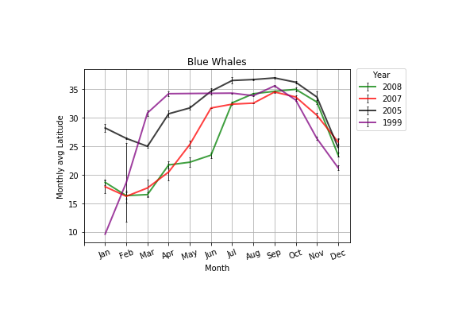In congruence with the cleaning process for terns, data points lacking required information were removed
* Again, we took the mean and deviation for latitude values by month spanning the entire data set
* The data revealed a possible initial trend towards the south concluding in a very similar latitude near the end
* Plot representing the above observations:

Monarch Butterflies:

* We investigated a dataset containing several years worth of sightings
* The data set was a record of pictures taken of the species, recording the geographic data of the picture
* 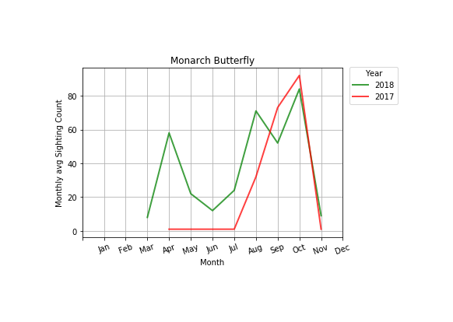Very difficult to conclude anything due to the spotty nature of the records
* Average total sightings were calculated by month to show a possible trend towards earlier/later migration
* A potential trend was revealed but still not conclusive:

Humpback Whales:

* We investigated a dataset containing several years worth of location data for pods of whales
* In congruence with the cleaning process for terns, data points lacking required information were removed
* 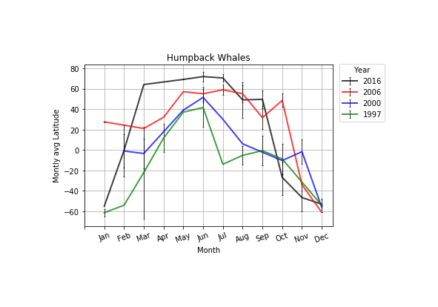Again, we took the mean and deviation for latitude values by month spanning the entire data set
* The data revealed a possible initial trend towards the north concluding in a very similar latitude near the end
* Plot representing the above observations: